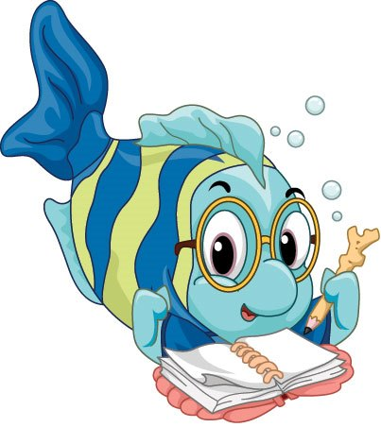

**All Saints’ Day School**

**Learning Through Play Since 1969**

# 🎔 🎔 February 2018 🎔 🎔

# 1969 Woodside Lane ∙ Virginia Beach, VA 23454

**(757)481-0577, ext. 2**

**allsaintsdayschoolvb.com  All Saints’ Day School**

**2018-2019 Registration**

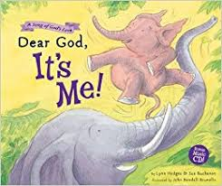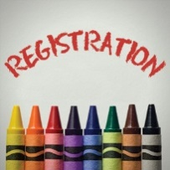Registration is coming along nicely for the fall of 2018. We know it seems early, but now is the time to lock it in. Remember that you need to have your paperwork and registration fee in by February 28th in order for you to receive the discount. Registration will be opening up to the public starting February 6th.

Please email [allsaintsdayschool@gmail.com](mailto:allsaintsdayschool@gmail.com) if you have any questions or need a new form.

**What Is Jr. Kindergarten?**

Teacher Marianne, of the Sea Otters will be presenting on exactly what her class is and how she prepares our students for kindergarten in both the public and private school settings. Please join her March 1st from 6:00 – 7:00 p.m. in her classroom, where the Sea Otters gather,

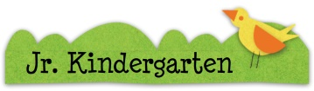for an informational evening that is bound to help you make decisions for your child’s/children’s future(s). Come with your questions. She has answers.

**June DAZE Camp Returns!**

As in the past, you are offered the opportunity to extend your child’s ASDS year in order to more closely match the Virginia Beach City Public Schools’ closing calendar. At ASDS, we call these days June DAZE. Although those in attendance are still learning, the format is more like that of a camp, and you may select the actual week or weeks you want your child(ren) to attend based on your family’s schedule.

Weekly pics and T-Shirts are returning! June DAZE is open to currently enrolled ASDS students who are potty-

trained. It will open to children currently enrolled in other preschool settings soon. Registration information and Themes will be coming out the first week of March!  Questions?  Contact Teachers Kate, Emily or Marianne.

**January Chapel**

January was a tough month for chapel- we only had 2 Mondays together! The time we did have was well spent. I shared the books Dear God, It’s Me by Lynn Hodges and my

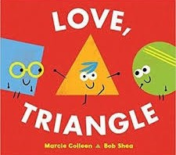new favorite: Love, Triangle by Marcie Colleen.  I love this book! Cleverly using shapes and geometry, it describes the conflict that occurs between friends.  It’s humorous and totally relatable if you’ve ever found yourself dealing with the problem of three friends trying to play together! Teacher Tiffany taught us a great new movement song about being a penguin.  Ask your child(ren) to show it to you!  Thank you to everyone who continues to send in small change donations for chapel.  That change adds up when it’s time to send it to the SPCA! We sang “Happy Birthday” to our January friends:  Kellen, Tinker, Logan, Andrew, Gigi, Teacher Beth, and Teacher Teresa.  Director Dianne

**Flu Season is Treacherous**

Watching the evening news can be terrifying as we learn of the impact of the flu on even the young and the healthy! Every story reminds us to wash our hands. **We thank you for remembering to wash your children’s hands BEFORE sending them to class.** Just this one step can go a long way in helping all of us to stay well.  It may also be helpful to your family to have them wash their hands and change clothes when they arrive home at the end of the day.  I know it adds to the never ending pile of laundry but it has been a very effective strategy for my family and me.

Director Dianne

**2018 PATTCH Fundraiser**

PATTCH is giving the Annual On-Site Auction a break this year and trying something new. We hope you will join us for this fundraiser on **February 22nd**. Money raised helps finance our Annual PATTCH-Sponsored Fall Festival, Thanksgiving Feast, Splash Day, and Playground Upkeep. PATTCH has also made some major purchases for classrooms as needs arise.

**After School Explorations**

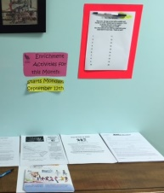After School Explorations is a way to extend your child’s day by one hour with one of our teacher-taught classes. Classes are registered for individually through the class sponsor and you may select from one to four days for your child(ren). Gather your paperwork from the Explorations Desk in the hallway near the red water fountain.

|  |  |
| --- | --- |
| C:\Users\cfelty\Desktop\after school amigos.jpg | Teacher Kate Keck hosts **“After School Amigos”** on designated **Mondays**. |
| C:\Users\cfelty\AppData\Local\Microsoft\Windows\INetCache\IE\992OL6QE\Musical_note_3_dennis_bo_01.svg[1].png  Music Makers | **Music Makers** is hosted by our own **Teacher Tiffany.** She is focusing on beginning piano on Tuesdays. **This class is FULL.** |
| C:\Users\cfelty\Desktop\ASDS 2017 2018\Newsletters\Back to School Newsletter\soccer-shots.png  C:\Users\cfelty\Desktop\ASDS 2017 2018\Newsletters\Back to School Newsletter\soccer-shots.png | **Soccer Shots™** is hosted by this outside agency, with which you will contract directly, on designated **Wednesdays and Fridays.** The new cycle began January 10th and runs through February 28th. **Registration Only available on-line** <http://vabeach.ssreg.org> Flyers available on the After School Explorations desk. **This, too, is FULL.** |
|  | Former ASDS Teacher, Kim Fisher, hosts “**Hands On Art”** on **Thursdays: February 8th, 15th, and 22nd.** |
| C:\Users\Moore\AppData\Local\Microsoft\Windows\Temporary Internet Files\Content.IE5\3UMHXVI8\cartoon-children-playing[1].jpg | ASDS Staff will host a **“Stay & Play”** on **designated Fridays.** Students must be signed up and paid for by noon on Thursday of each week. |

**Play: The Work of Lev Vygotsky**

We visited with Lev Vygotsky a bit last month. Here is a little more of his philosophy; though long-standing; still highly respected by present-day educators and developmental psychologists.

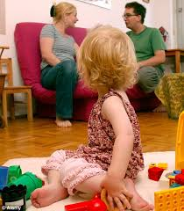**The social interaction of play develops cognition**   
Vygotsky was also interested in the role of social interaction on cognitive development and argued that development first takes place socially.  That is, children observe parental behavior, listen to parents' speech, and then try to imitate them.  As children practice through imitation, parents will guide children, correct them, and provide challenges.  Through child-centered play, children take on different roles and try out different language uses, all of which help them on the journey from being externally regulated to internally regulated in cognition.  Through play, children become more competent in their language use and begin to regulate their own thought processes.   
**Problem solving skills and play**

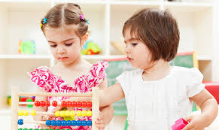Vygotsky proposed that a child's performance differs between instances in which he tries to solve a problem alone and when another child or adult assists the child.  He refers to this difference as the "zone of proximal development."  How does this relate to play?  If a child is learning to complete a task, such as building a bridge with blocks, and a more competent person provides assistance, then the child is able to move into a new zone of development and problem solving.  Vygotsky refers to this process of assisting as "scaffolding," which helps bridge the difference between a child's current level of problem-solving and his potential for more complex problem solving.   
Imaginative play is essential to cognitive development, but it is becoming endangered by our busy lives.  Children who do not engage in imaginative play because their time is overly structured or spent watching television or other forms of media are not developing the language and reasoning skills that are so critical to early childhood development.

<http://www.childdevelopmentmedia.com/articles/play-the-work-of-lev-vygotsky/>

**❓ ✂ 🎜 🎭**

**From the Classrooms 🖐 🎔 ✍ 🕙**

**Teacher Emily**

January was a fun month for the Dolphins! We learned what temperature it has to be for it to snow and how to be safe and have fun during snow storms. We read Let it Snow to give us some ideas of what activities we could do in the snow. We also froze and un-froze our own ice from water: turning liquid into a solid and back again. The students were so eager and excited to check on their cups of water that we left outside for a couple of days!

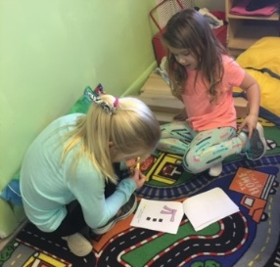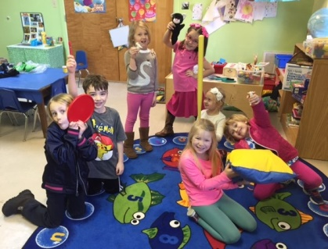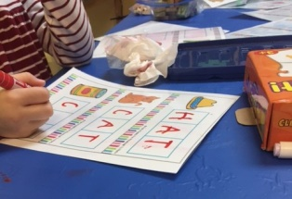The Dolphins also love rhyming. The rhymes we worked on this month were "Humpty Dumpty" and "Hey Diddle Diddle". We always start off with singing the rhyme and making sure we all know the words. I point to the words while we are singing along, so the students can read along with me. We then discuss which words rhyme. After I'm sure everyone knows all the words, I give the students a chance to come up and use the pointer to point to the words while we are singing, which is always so much fun. I then ask for volunteers to "read" the poems to the class from our Nursery rhyme book. By this point they have already memorized the words, but by having them "read" to their class it instills confidence in their reading skills.  
We discussed “Humpty Dumpty” and what would have happened if they were able to put him back together in the end. I asked them questions such as; "What would he say?" or "What would Humpty Dumpty do next?" They were challenged to re-write their own endings and draw a picture. This worked on our story telling skills and writing skills. It was very fun to see and discuss what endings the students came up with.   
We had a lot of fun with "Hey Diddle Diddle" by acting out the story line. Each of the students got to play a character from the rhyme. This activity brought out a lot of singing and giggles! The students are always so eager to participate in activities that get them physically involved.  
This past week we began our reading buddies with Teacher Marianne's class! The Dolphins read the page first to their younger reading buddy from the Sea Otters and their partners repeated after them while pointing to the word. They highlighted the two sight worlds "I" and "see" on each page. All the children had so much fun with their new buddies, and are eager to keep the weekly activity going.  
We have a big week ahead of us as we continue to learn our word families and to learn all about the Artic and the animals that live there, as well as what their habitats are like!

**Teachers Marianne & Teresa**

Despite Old Man Winter’s best efforts, the Sea Otters did not let a few snow days stop us from moving forward with our ABC journals, learning about hot and cold temperatures, and discovering how animals adapt to cold climates. In fact, January’s snow days provided the perfect hands-on experience for our science experiments and observations.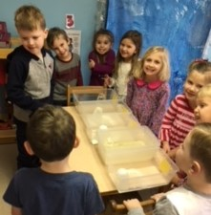 We began the month of January discussing hot and cold temperatures and sorting different objects and events that can be found in different temperatures. Then, we conducted several different experiments to see what happens to different objects in the heat and then in the freezing cold temperatures. First, our class used a blow dryer to test the following objects to see if they would melt: a block, a marble, a slice of cheese, butter, a sock, a marshmallow, and chocolate. We observed that chocolate, cheese, butter and marshmallows all react to hot temperatures by melting. Next, we conducted an experiment to see which of the following materials would melt ice fastest: sugar, salt, borax, water, vegetable oil. We observed that salt and water melted the ice the fastest. In a class discussion after this experiment one of our students pointed out “that even though water was one of the materials that melted the ice the fastest, you can’t spray your driveway with water to melt snow because it would just freeze back up again. That is why people use salt on their driveways when it snows.” (We have a bunch of smart cookies in here!)

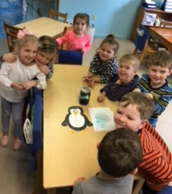After learning about hot and cold temperatures, we read many non-fiction books about penguins and found out how they adapt to cold temperatures. We even conducted an experiment and tested how the oil glands on a penguin repel water and keep it dry. Staying dry is imperative to staying warm in the Antarctic. We sprayed a paper penguin and a penguin coated in waxy crayons with blue water. We observed that the penguin coated in wax and oil repelled the water and the paper penguin absorbed the water. Our class also had fun pretending to be penguins in a relay race as we waddled from start to finish with a pretend egg on our feet and tried to pass the egg off to our partners without it breaking.

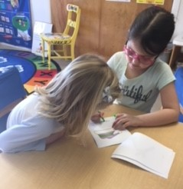Adding to our fun news, our class began learning our pre-primer sight words this month! So far our class has mastered the following words: big, little, my, is, can, look, are, I, a, see, and. And, with the help of our new kindergarten reading buddies in the Dolphins’ class, we are learning how to identify these words in text and practice our reading skills. Each Wednesday Teacher Emily and her awesome kindergarteners visit us and help us read a new emergent reader book. Our kindergarteners are also helping us decode words by sounding out initial letters and looking at picture clues.

So, despite the snow’s best efforts, we have learned a ton this month through play and hands on activities. I am super excited to see all that the Sea Otters will achieve next month!

**Teachers Susan and Cathy**

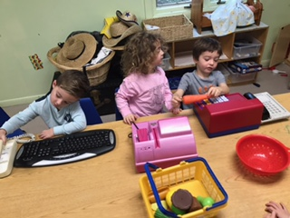Thank you so much for all the condolences, kind words, and prayers. My father was the kindest person I have ever known! He is truly missed by all that knew him!

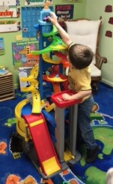The Stingrays have been working on writing their names. They are really working hard on their handwriting. Please work on their pencil grip at home. I hope they are enjoying their homework!

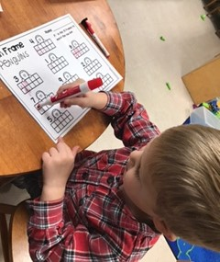We have been working on the letters W, G, and reviewing our other letters. Counting and recognizing numerals 0-10 has been a lot of fun, too. Learning all about snow and penguins during the wintertime has been a blast. We are looking forward to Groundhog Day, Valentine's Day and all the fun we will have in February!

**Teachers Sandra, Beth & Tiffany**

Starfish were very busy learning during the month of January despite two holidays and a blizzard. We started our year off anticipating the forecasted blizzard of 2018 by reading, The Jacket I Wear in the Snow and The Snowy Day. We discussed appropriate clothes to wear during a snowstorm and the students separated summer and winter clothes into different groups. We made snow using baking soda and shaving cream before we knew we were going to get several inches of snow and be snowed in for a week. We made colorful mittens using a marble and paint, and we discussed the winter season while learning about the letter W. The children went outside and collected a bowl of leaves and sticks and we filled the bowl with water and left in outside. With the bitter cold we had, they were able to see that water will turn to ice in freezing temperatures.

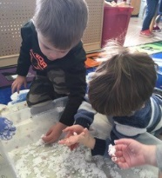The first day back from our snow vacation we read, Sneezy, the Snowman, and made melted snowmen out of shaving cream and glue. We moved on to our unit about Arctic animals. Arctic Fives Arrive was read, and we learned about the Snowy Owl, Narwhal, Arctic Fox, Caribou, Harp Seal, Beluga Whale, and Walrus. The children used hammers and water drops to release the arctic animals from the frozen icebergs and played with the sea animals using water beads for the ocean. We discussed the letter I, and all the “cold” words that started with I, such as ice cream, iceberg, icicle, and igloo. Our colors of the month, white and blue, went perfectly with our arctic theme.

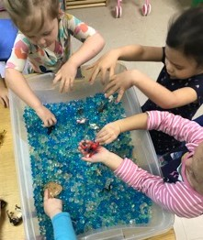The letter O was introduced when we read, Owl Babies, and snowy owls were made, but saved for the big reveal at the ASDS art show. Oranges were peeled and eaten for a special treat.

The number 7 and the star shape were discussed and sung about during Circle Time. A new song about the seasons was introduced and sung each day. Every day we sing and talk about the weather, calendar, how many students are at school that day, letters, numbers, themes for the week and so much more. We love seeing how the students have grown and learned so much since the beginning of the year. I see penguins, groundhogs, dentists, and Valentine’s in the forecast for February.

**Teachers JoJo & Patsy**

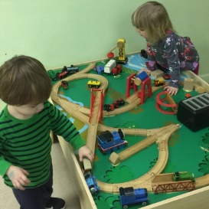Phew…..what a month January was with all of the snow days! Teacher Patsy, Weezie, and I want to thank you again for all of the presents and kind cards that you all gave to us during the holidays. Your generosity is greatly appreciated. Thank you so much!

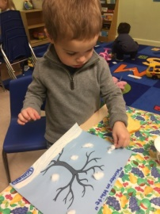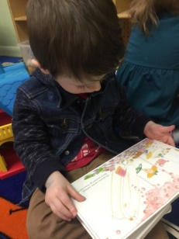This month we focused on the letters Rr, Ss, and Ww this month. Our colors were blue and white. Rectangles were added to our shapes and the number “6” to our numerals. We sang and learned the motions for “I’m a Little Penguin”. The students learned from our book about penguins that penguins live in cold and warm environments and that they swim instead of fly! Other books we read this month were Green Eggs and Ham and Winter White. The students made green eggs and ham, and their plates are displayed on the “Sea What We’ve Done” bulletin board. They also made snow scenes which are displayed above the side cubbies. The letter “P” was used for the students to make penguins. The students are continuing to thrive, and we are so proud of their accomplishments and growth. We look forward to another amazing month in February!

**Music with Teacher Tiffany**

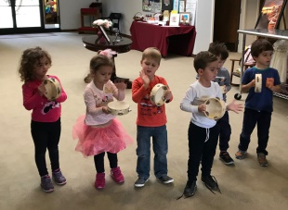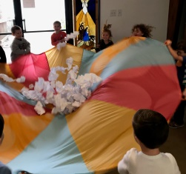With so many snow days we only had two music classes this month, but it was still packed full of fun musical themes!  We made snowballs out of white paper and sang “Counting Snowflakes”!  The students did a great job counting to 20.  We used the snowballs in the parachute to show crescendo and decrescendo (becoming louder and softer). The students loved this activity because the snowballs were bouncing everywhere.  Have your child sing you the “Penguin Song”. They loved acting out this song with right/left flippers!  We danced to the song “Snow Dance” with tambourines.  This helped with keeping steady beats. I hope this dance does not bring more snow our way! We sang “Five Little Snowman” and the children were pretending to be the sun as each snowman melted away!

**Spanish with Maestra Kate**

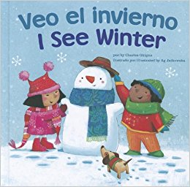¡Feliz año nuevo!  Happy New Year!  Enero (January) began with winter weather on everyone's mind, so we started this month with a book called Veo el Invierno (I See Winter) and did a felt story kit with objects such as copos de nieve (snow flakes), patinas de hielo (ice skates) and trineos (sleds), to go along with each page of the book.  We then played a game where I hid a bolo de nieve (snow ball) made from felt under various colored felt mittens.  The children had to adivinar (guess) in Spanish which color mitten they thought it was hiding under.  Though we sing our color song at the beginning of Spanish class each week, it's great practice to recall the colors out of the context of our song!For the rest of the month, we focused on common phrases in Spanish.  We read a book called Yes, Please and No, Thank You!, but I translated each page so that the children had to answer "sí, por favor" or "no, gracias" to various scenarios on each page.  We also played a game similar to “Duck, Duck Goose”, but instead, we pretended to sleep on the floor in a circle and used the phrases “buenas noches” (good night) and “buenos dias” (good morning) to either keep our amigos asleep on the floor or wake them up and tag them “it”.   The next week we read Me Gusta Cuando, a sweet book that illustrates all of the things that kids like to do with their parents (and maybe a couple of things that parents wish their kids enjoyed, such as trying new foods!).  Then we played a game where everyone got to see a portion of a photo and had to venture a guess about how they felt about the partially obscured object in the picture.  Based on their guess, they had to put themselves into one of four groups:  me gusta mucho (I like it a lot), me gusta (I like it), no me gusta (I don't like it), or no me gusta para nada (I don't like it at all).  They then got to see the whole picture and could put themselves in a different group based on how they really felt about the subject of the photo.

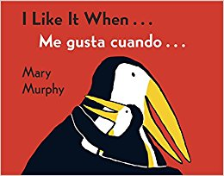**frases del mes (phrases of the month)**

me gusta (meh goos-tah) - I like

no me gusta (no meh goos-tah) - I don't like

sí, por favor (see por fah-bor) - yes, please

no gracias (no grah-see-ahs) - no, thank you

buenos dias (bwen-ohs dee-ahs) - good morning

buenas noches (bwen-ahs no-chez) - good night

nieve (nee-eh-beh) - snow

**Library with Teacher Sandra**

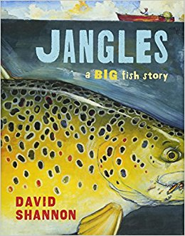January was such an abbreviated month due to the unexpected blizzard, but we managed to fit in a few library days. We started the month reading, Jangles: A Big Fish Story, by David Shannon. This book is about the legend of Jangles. He is a huge trout that lives in a lake and everyone from far and near come to the lake to try to catch him. He gets the name, Jangles, because you can hear him jingling and jangling, when he is swimming because he has so many hooks and lures in his mouth. One evening a boy feels a tug on his line and is terrified when he realizes it is, Jangles. But he soon realizes there is nothing to fear as Jangles takes him on an adventure at the bottom of lake.

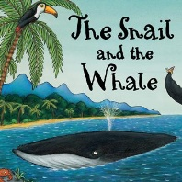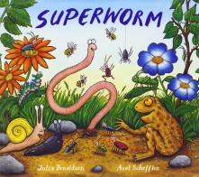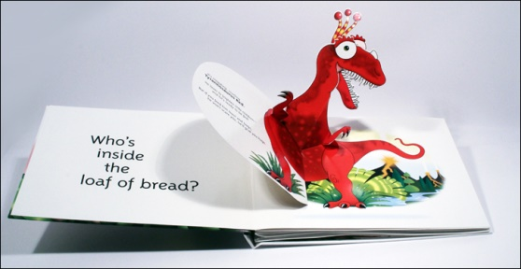Julia Donaldson is one of my favorite authors, and this month we read The Snail and the Whale, and Superworm by her. Both of these books teach children about the importance of teamwork to help out others who are in need.

What was hiding in a toaster, a pickle jar and a china teapot? Dinosaurs, of course! Flapdoodle Dinosaurs, by David A. Carter is a bright and colorful pop-up book filled with dinosaurs hiding throughout the story.

Try to read with your child for short periods, several times each day. Choose stories you enjoy reading to make it a more enthusiastic experience for both of you. If your child loves a book so much you have to continually read if over and over again, look for books by that author and get a few new ones to add to your library.

There is nothing better on a cold winter day than to get a good book off the shelf and snuggle in a blanket with your child and spend the afternoon reading.

Happy Reading!

**“Adjusted” Weather Policy**

 The City of Virginia Beach is geographically far-reaching and weather conditions in one part may differ greatly from weather conditions in another part. When the public schools are closed, it is because the entire school division must be considered as a single entity. Also, because the same school busses are used for elementary, kindergarten, middle, and high school runs, there is an impact on the timing of the call in order to make certain all students are safe.

Because our families come from a relatively small geographic area, we have a bit more flexibility. Therefore, in consultation with the church Rector, Dr. Sawyer, and the Chair of the Day School Commission, Dr. Felty, there **MAY** be a time when we will make an on-site decision with regard to weather closures. SAFETY will ALWAYS be our first priority. Please do NOT phone us to inquire. We will notify you via e-mail, Facebook, and/or class text.

**February’s For the Fridge…**

|  |  |  |  |
| --- | --- | --- | --- |
| **Date** | **Kids’ Version** | **Event** | **Notes** |
| February 14th  Wednesday | 🎔🎔🎔🎔🎔 | **Valentine’s**  **Day** | There will be LOTS of fun! |
| February 19th  Monday | C:\Users\cfelty\AppData\Local\Microsoft\Windows\Temporary Internet Files\Content.Word\presidents' Day.jpg | **Presidents’ Day** | ASDS is CLOSED. |
| February 22nd  Thursday  7:00 – 9:00 | C:\Users\cfelty\Desktop\ASDS January Newsletter\silent auction.jpg | **A FUNdraising Night Out** | Join us a Simple Eats  for an evening of fun!  This is a PATTCH fundraiser and a ticketed event. See article above. |
| March 1st  Thursday  6:00 – 7:00 |  | **Jr. Kindergarten Information Night** | Parents are invites to a presentation by Teacher Marianne in the Sea Otters’ classroom. |
| March 21st and 22nd  Wednesday and Thursday | C:\Users\cfelty\AppData\Local\Microsoft\Windows\INetCache\IE\FYE0LXS5\female_photographer_silhouette_by_allblissfulmemories-d4jtkpj[1].png | **Spring Pics with**  **Emily Hall** | More to come as the date draws closer. Think Mothers’ Day Gifts for Grandma and Great Grandma! |
| March 30th – April 8th  Friday | C:\Users\cfelty\Desktop\spring.jpg | **Spring Break** | Enjoy being Family! |
| April 9th  Monday | C:\Users\cfelty\Desktop\Back to school.jpg | **School**  **Re-opens** | Welcome Back! |



