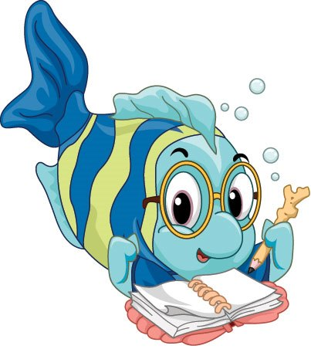

**All Saints’ Day School**

**Learning Through Play Since 1969**

 **January 2019** 

**1969 Woodside Lane ∙ Virginia Beach, VA 23454**

**(757)481-0577, ext. 2**

**allsaintsdayschoolvb.com  All Saints’ Day School**

**Christmas Program**

Our very own version of the Annual Radio City Music Hall Christmas Spectacular was held at 11:15 a.m. on Wednesday, December 19th to a packed audience of parents, friends, and family! It was such fun seeing all of the children dressed up. Their performance matched their excitement as they shared the joys of the season through music. Thank you to our Music Teacher Ms. Dana for all of her hard work, and to the classroom teachers for reinforcing her efforts as the performances were practiced to perfection.

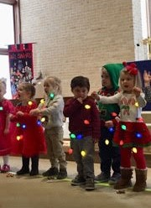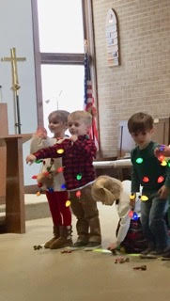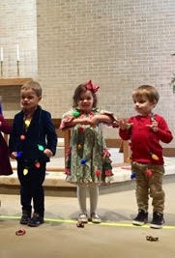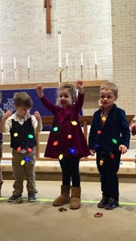

**Holiday Gift Shop!**

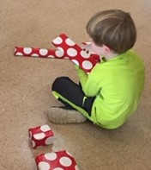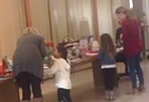This year's Holiday Gift Shop was held on **Wednesday, December 12th and Thursday, December 13th during the school day.** I'm sure you all were excited to open the very special presents your children selected for you from our Holiday Gift Shop! Thank you to everyone who sent items in and to Liz Flowers and her very special elves who made it such a success: Courtney Coster,

Page Gritte, Katie Davenport, Christina Zepf, Cindy Mason, Jenni Suhr, Brooke Leffler, and Jill Wood. The children took the process very seriously! Choosing and supervising the wrapping was important business! I can't wait to hear all about what you received.  I have to say I was impressed by the quality of the items you all sent in. That's a definite change for the better from when my child was a student here! ☺

Director Dianne

**After School Explorations**

After School Exploration opportunities are available Monday through Friday. This is a way to extend your child’s day by one hour with one of our outside vendor or internal teacher-taught classes. Classes are registered for individually through the class sponsor, and you may select from one or to four days for your child(ren). Gather your paperwork from the Enrichment Desk in the hallway near the red water fountain. All children who participate must be fully potty-trained.

|  |  |
| --- | --- |
| C:\Users\Caryl Felty\Desktop\All-logos-Kids-art-club-475x500-mob.jpg | Art with ASDS Jr. Kindergarten Teacher, Marianne Padrick, held on **Mondays.** |
| C:\Users\Caryl Felty\Desktop\aerobies-clipart-healthy-child-4.jpg | KID FIT ™ is hosted by an outside agency, with which you will contract directly for Certified Professional Trainer, Jessica Glenn, held on **Tuesdays starting January 8th.** |
| C:\Users\cfelty\Desktop\ASDS 2017 2018\Newsletters\Back to School Newsletter\soccer-shots.png | Soccer Shots™ is hosted by this outside agency, with which you will contract directly, on designated **Wednesdays and/or Fridays. A new cycle is beginning on January 9th.** |
| C:\Users\Caryl Felty\Desktop\68ffef1ef41b7520331217b17752d741.jpg | STEM with ASDS Jr. Kindergarten Teacher, Marianne Padrick, held on **Thursdays**. |

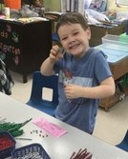**Chapel**

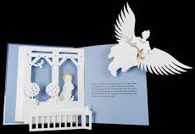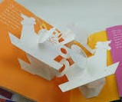December was mainly spent preparing for our Christmas program.  Our music teacher, Dana, and all of the teachers have spent LOTS of time getting our students prepared for the big show! I did share a couple of phenomenal pop up books by one of my favorite authors, Robert Sabuda: The 12 Days of Christmas and The Christmas Story.  If you ever get a chance to look at any of his works, you will be amazed at the beauty of the pages.  I would love to see how in the world they are able to mass produce these books.

also sang "Happy Birthday" to all of our December friends: Teacher Marianne, Silas, Charlie, Wyatt, Nolan, Johnny, Charlotte W., Jackson N., Ford, and Zealand.  I wish all of our friends and families a very Merry Christmas and a Happy New Year!

**❓ ✂ 🎜 🎭**

**From the Classrooms 🖐 🎔 ✍ 🕙**

****

**Ms. Cathy**

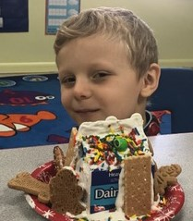The Dolphin class was all about Christmas in December.   We continued our usual routines in reading, math, science, and in the kitchen; adding a little Christmas cheer to all of our activities.

Every morning we continued our independent reading.  Each of the children comes to school every morning excited to get into his/her book.   A few of the kids have moved on from our phonetic based books to chapter books.  It's a very exciting time and I'm confident all the children will move on to trade books as the year progresses.

In math we continue to build on basic math skills as we introduce higher level math.   We are doing lots of addition and subtraction.  Every morning the children are creating their own subtraction and addition sentences based on our "Question of the Day".   The children are also having fun working on some of our silly word problems.

In Science our experiments have revolved around candy canes, hot chocolate, gingerbread men, and gingerbread houses.  The Dolphins have come up with hypotheses on what will melt a candy cane the quickest, what will sink and or melt in hot chocolate, and what items are strong enough to hold up an adequate gingerbread house.  Of course, lots of taste tests and fun were had by all.  Also, in science we were able to light a single Christmas light with a AA battery as well as a 9-volt battery.  We discussed closed circuits versus open circuits and why the light was much brighter when we used the 9V battery.  They were able to record their hypothesis and results for all their experiments in their science notebooks which will come home in May.

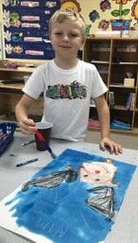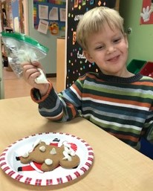The Gingerbread Man came to visit the Dolphin class! I believe he may be a cousin to the more famous Elf on the Shelf.   Our Gingerbread man came to watch our class and report back to Santa all the green choices the children were making.  The Gingerbread man left us notes daily telling us how happy he was when he witnessed each of us using kind words and sharing.   He also left us gingerbread cookies to decorate.

In December we did a few guided drawing activities.  These are great projects to practice multi step directions.   The children drew Santa, an elf, an ornament, and Rudolph.  I was very impressed with all of their drawings.

Teacher JoJo came for a visit and read to the children about Hanukkah.   She discussed the meaning and the lighting of the menorah.  Teacher JoJo also brought a dreidel to our class and taught the children what the symbols on the dreidel meant and how to play.  We spent a morning playing and laughing.  Lots of thanks to Teacher Jo Jo for sharing with us.

We finished our month with a ride to the North Pole with the Sea Otter class.   All the children received a ticket to board the Polar Express.  Upon arrival, the children had several activities among which to choose. In one classroom there was a train set and ornament making, while in the other class cookie decoration, jingle bell toss, and gum drop architecture.  A great time was had by all.  Everyone agreed we would need to visit again next year.

I would like to wish all of our families a very Merry Christmas and a Happy and Healthy New Year.

**C:\Users\cfelty\Desktop\sea otter.jpgMs. Marianne & Ms. Teresa**

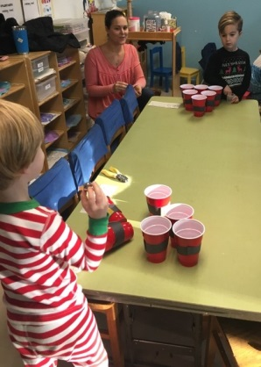December was full of merriment in the Sea Otter Classroom! We spent the month of December learning about how different countries around the world celebrate Christmas. We started by transforming our dramatic play area in to an airport. In this area the students could practice flying an airplane, checking luggage, adding stamps to their passports, and pretending to visit the different countries they learned about.

The Sea Otters learned about Christmas traditions in Mexico, the Philippines, Germany, the Netherlands, the United States of America, and Switzerland. For every country we learned about, the Sea Otters made a craft to take home. By the end of our unit each student had a suit case of treasures from their travels to take home and share with their families.

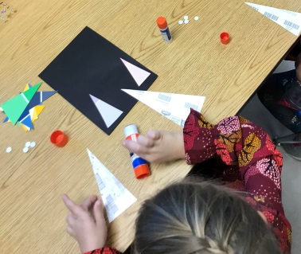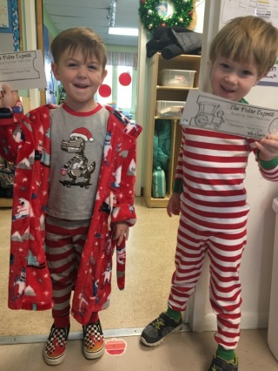At the math center, the Sea Otters finished learning how to read, write, create, and form numerals 1-10. They are all doing such a great job in their math journals and are ready to begin learning how to identify numerals 11-20 in January. Our math and science journals are a fun way for the students to gain hands-on math and science experiences. We use drawings to record our findings and answers when we conduct science experiments, or when we use manipulatives to create different numbers. This month we conducted many fun Christmas science experiments such as making the Grinch’s heart grow, testing which Christmas objects sink or float, and making candy canes fizz.

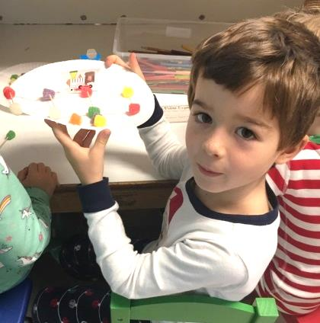During the last week of school our class joined forces with Teacher Cathy’s Dolphins and had fun with a mini Polar Express unit. After reading the story in our own classes, on the Monday before school let out, the students were invited to wear their pajamas to school the next day. As each child arrived at school, they were greeted with a Polar Express train ticket that they took to different stations with them. The Dolphins and Sea Otters had the choice to engage in a fun STEAM activity and create train tracks using paper trains, toothpicks and gumdrops, play a jingle bell game, decorate sugar cookies, make ornaments, or play with toy trains. What a fun way to end an exciting month!

The Sea Otters have come so far in these past few months! We can’t wait to see what 2019 has in store for them!

**Ms. Susan & Ms. Elaine**

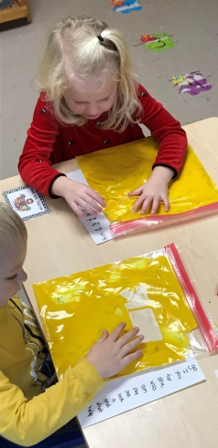December was a whirlwind for the Stingrays! They worked so hard on our Christmas Program, and we all agreed that we did awesome! Our Christmas Party was great fun too. We read lots of Christmas books

and created pretty Christmas art projects!

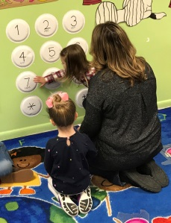We worked so hard on our sight words, playing many fun games with them. Our students are are starting to really recognize them. It’s very exciting!

We’ve been counting everyday we’ve been at school. We are up to 60 something. We also have been working on learning our Moms’ phone numbers.

We look forward to continuing to grow and learn in 2019!!

**MS. Sandra & Ms. Beth & Ms. Terry**

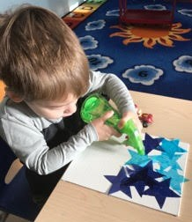The Starfish students were very active during the short weeks we had at school during the month of December. We started the month with a visitor from the North Pole named Timmy. He was our class elf who taught the children that Christmas wasn’t just about receiving presents. He had a note attached to him each day that had a task for the students to do to spread holiday cheer throughout the school. They sat next to someone new a snack each day, made Christmas cards to take home to their families, said “please” and “thank you”, high fived their friends during Circle Time, and they delivered candy canes to the other classes at ASDS. The Starfish enjoyed looking for Timmy every day they came into the class. In return for being so giving, Timmy sent them gifts the last week of school. They received three games to play during Center Time and on rainy days.

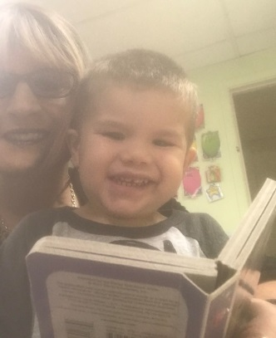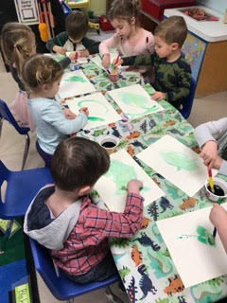The children spent a lot time reviewing the shapes, colors, and numbers we have been working with since September, and were introduced to the letters E and C.

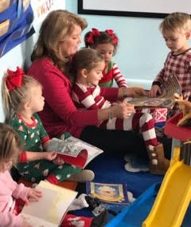The students created a festive 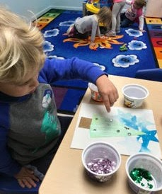Christmas tree on canvas for their parents to display during the holidays. We spent a few weeks creating this process art project. It included water-colors, bleeding tissue paper, modge-podge, fine glitter and sequins. The children also made beautiful ornaments using acrylic paint. They picked out two colors and we poured them into each bulb. Then the children shook the bulb until the inside was covered with the paint. The ornaments were topped off with a glittery bow to hang on the tree.

Pajama Day was a hit with the kids. Everyone wore their PJ’s to school. We popped popcorn and watched “Stickman”, which is my new favorite Christmas story. We read the book before watching the movie. Children brought in their blankets to share while eating their popcorn and viewing the movie.

We spent many days during the month of December practicing for our Christmas program. The Starfish practiced our songs, walking in a straight line, and walking to the end of our pew before sitting down. It sounds pretty easy, but they were huge tasks to ask of a three year old. Teachers Beth, Terry, and I were so proud of our students. The children did everything perfectly the day of the show. We ended our month with a holiday celebration in our classroom. The children made candy cane ornaments using beads and pipe cleaners, and they had some snacks and cookies to finish off 2018 at ASDS.

C:\Users\asds2011\AppData\Local\Microsoft\Windows\INetCache\IE\CBYQ5DNO\SEA_TURTLE_thumb[1].jpg**Ms. JoJo & Ms. Patsy**

December was such a festive month for the Sea Turtles! We worked on the letters “Cc” and “Gg” and will review them, in addition to more letters, in January. We added green to our colors, stars to our shapes, and the number 6 to our numerals.

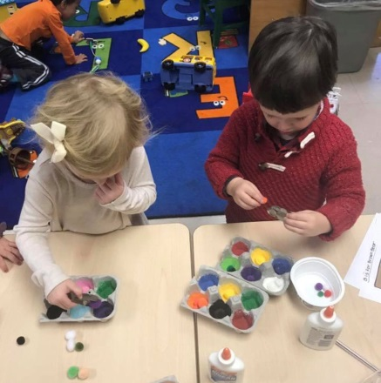Our students practiced super hard for the Christmas program. They sang and learned the motions to their songs! We had fun decorating trees with fingerprints, painting and making wreaths with bows, jewels, and sequins, making fruit cup ornaments, and cards made out of Christmas tree cut outs. We also painted “Gg” and gingerbread men and colored them as well. The students enjoyed decorating their frames as gifts for their parents. We hope the students like the books that they received for their present.

Here are some of the books that we read this month: The First Christmas, This is the Stable, The Christmas Alphabet, First Library Christmas, What Santa Can’t Do, Christmas Lights, Santa Duck, and The Gingerbread Man. Thank you for all that you do to support your child and us! We love our families! We hope you have a blessed holiday!

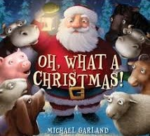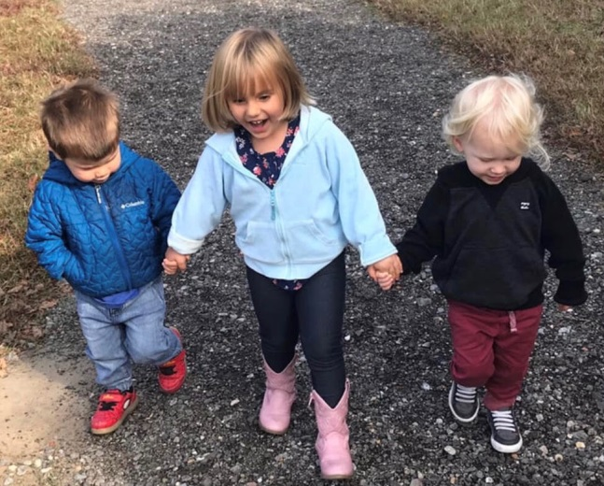

**Music with Ms. Dana**

In December, we spent most of our class time rehearsing for the Christmas program. We learned about how we use different voices for speaking, yelling and singing.  Sometimes children will yell when they sing because they are trying to be loud. So, we talked about how we need to use our “pretty” voices when we sing. If your throat hurts, that means you are yelling, not singing.

We also learned two new finger-plays in December:

*“ASDS Five Little Christmas Trees”*

C:\Users\Caryl Felty\AppData\Local\Microsoft\Windows\INetCache\IE\FTJAQU1F\12629-illustration-of-a-plain-christmas-tree-pv[1].pngC:\Users\Caryl Felty\AppData\Local\Microsoft\Windows\INetCache\IE\FTJAQU1F\12629-illustration-of-a-plain-christmas-tree-pv[1].pngC:\Users\Caryl Felty\AppData\Local\Microsoft\Windows\INetCache\IE\FTJAQU1F\12629-illustration-of-a-plain-christmas-tree-pv[1].pngC:\Users\Caryl Felty\AppData\Local\Microsoft\Windows\INetCache\IE\FTJAQU1F\12629-illustration-of-a-plain-christmas-tree-pv[1].pngC:\Users\Caryl Felty\AppData\Local\Microsoft\Windows\INetCache\IE\FTJAQU1F\12629-illustration-of-a-plain-christmas-tree-pv[1].png

*Five little Christmas trees standing all alone*

*Their hearts were very sad ‘cause they hadn’t found a home*

*Then chop went the axe and down fell the tree*

*And off one went with a happy family (etc.)*

And:

C:\Users\cfelty\AppData\Local\Microsoft\Windows\INetCache\IE\K4GZIG4J\blue-snowflake-33[1].jpg *“See the Snowflakes Falling”* C:\Users\cfelty\AppData\Local\Microsoft\Windows\INetCache\IE\K4GZIG4J\blue-snowflake-33[1].jpg

*See the snowflakes falling*

*See the candle glow*

*See the wreath upon the door*

*It’s Christmas time I know!*

All the classes enjoyed dancing to Koo Koo Kangaroo’s song “Please Come to my Christmas Party”. You can find it here:

<https://www.youtube.com/watch?v=RLSOXKq9K50>

We practiced keeping a steady beat while listening to “Sleigh Ride” by Leroy Anderson. The children enjoyed hearing the horse neigh at the end!

In January, we will be learning some new songs and games to keep the winter blues at bay.

** Library with Ms. Sandra**

We read a few amusing books about Christmas and Santa Claus during December. I started off reading,There was an Old Lady Who Swallowed a Bell, by Lucille Colandro. Yes, the little old lady is back, and she is swallowing Christmas items to help Santa make his way to all the children on Christmas Eve. She swallowed a bell, bows, a sack, a sleigh, some toys, and even reindeer.

Santa is in big trouble in the book, Oh, What a Christmas! by Michael Garland. Santa is out on Christmas Eve with his sleigh and reindeer when the reigns snap and the reindeer take off without him. He crashes into a barn and convinces the barnyard animals to help him guide his sleigh to deliver toys to the good girls and boys.

My favorite Christmas book is Stick Man, by Julia Donaldson. Stick Man isn’t an ordinary stick…he’s a man, and he lives in his family tree with his lady love and children three. He goes for a jog one day and is mistaken by a dog for a stick. The dog picks him up to play catch. A girl throws him into the river for a race. A swan swoops him up to make a nest. A dad uses him as a mast for a flag at the top of a sand castle. He is used for many purposes, including firewood, but Santa saves him on Christmas Eve and returns him to his family and tree.

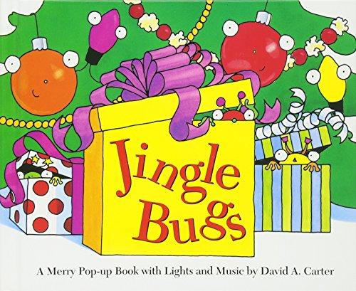How would you like to be a gingerbread man sitting on a cookie plate on Christmas Eve? Well, A Cookie for Santa, by Stephanie Shaw tells the story of one very frightened gingerbread man. Fortunately, he proves to Santa that he shouldn’t be a snack, but he could be a great help for him on Christmas Eve.

Jingle Bugs and The 12 Bugs of Christmas are pop-up books that are fun to read during the Christmas season. The students enjoyed discovering a new type of holiday bug each time the page was turned in each book.

Let’s start 2019 off on the right foot and read to our children each and every day! Happy Reading!

****

**Espanol with Maestra Kate**

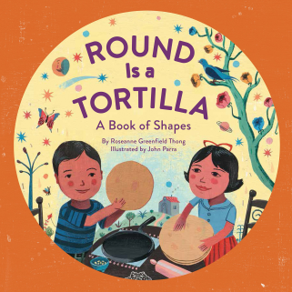We had fun, literally, in all shapes and *formas*in Diciembre!  Christmastime lends itself nicely to discussions and games with shapes and, as a bonus, the kids easily pick up shape vocabulary in Spanish because most of the words are cognates (very similar in both languages).  We read Round is a Tortillaand played a game where the children worked in teams pulling shape adornos (ornaments) out of stockings, identifying them in Spanish, hanging them on a miniature tree and shouting "FELIZ NAVIDAD!"  We also played a game where I pretended to be a train conductor and the kids had to 'pay' me with tickets of various shapes that they first had to identify in Spanish.  We did shape, color, and number hopping, which allowed my amigos to review all of the vocabulary we've learned so far this year.

|  |  |
| --- | --- |
| **“Prepare your child**  **for the path…**  **…not the path**  **for your child.”**  Attributed to Betsy Brown Braun | C:\Users\cfelty\Desktop\ASDS January Newsletter\winter path.jpg |

We also read books that illustrate Christmas festividades in Mexico and we then compared and contrasted them with Christmas in the U.S.  'Twas Nochebuena depicts traditional nochebuena (Christmas Eve) celebrations with tamales, piñatas, fireworks (I apologize in advance if your children are asking for sparklers or a piñata to add to your family's celebrations!), and las posadas, which is a nine-night celebration that people where people gather together to honor the journey that Mary and Joseph made through Bethlehem looking for shelter.

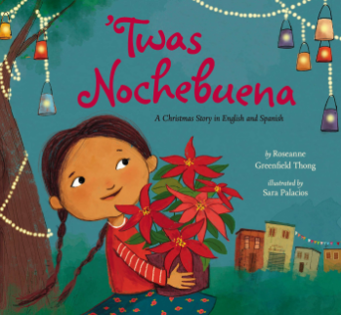Wishing you a feliz navidad y prospero año nuevo!

**Palabras del mes**

cuadrado (quah-drah-doh) - square

círculo (seer-koo-loh) - circle

triángulo (tree-ahn-goo-loh) - triangle

óvalo (oh-bah-loh) - oval

estrella (eh-streh-ya) - star

* **For The Fridge…** 

|  |  |  |  |
| --- | --- | --- | --- |
| **Date** | **Kids’ Version** | **Event** | **Notes** |
| January 2nd  Wednesday | C:\Users\Caryl Felty\AppData\Local\Microsoft\Windows\INetCache\IE\CMC9CQ0A\School_20Kids[1].gif | **School Reopens** | We’ve missed you! |
| January 21st  Monday | **C:\Users\cfelty\Desktop\images (1).jpg** | Martin Luther King Day | ASDS is CLOSED |
| February 1st  Friday | C:\Users\cfelty\Desktop\download (1).jpg | Staff Inservice Day | ASDS is CLOSED to STUDENTS  The VBCPS changed their day  so we changed ours. |
| February 14th  Wednesday | 🎔🎔🎔🎔 | **Valentine’s**  **Day** | There will be LOTS of fun! |
| February 18th  Monday | C:\Users\cfelty\AppData\Local\Microsoft\Windows\Temporary Internet Files\Content.Word\presidents' Day.jpg | **Presidents’ Day** | ASDS is CLOSED. |



